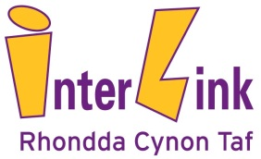
INTERLINK SUPPORT TO COVID-19 VOLUNTEER COMMUNITY GROUPS
Interlink are providing support to all Covid-19 Volunteer Community Groups in RCT who want support. We will help you in any way we can. For example, we offer:
- Guidance for Groups - we can provide you with easy to follow guidance for running a Covid-19 volunteer community group, doing a risk assessment and a model volunteer agreement.
- Grants - we have small grants available, simply send a short request by email to: grants@interlinkrct.org.uk
- DBS checks for volunteers - help you register and pay for key volunteers for a DBS check and check any existing DBS checks help by your volunteers.
- Interlink staff - we will put you in touch with an individual member of staff to support your group.
- Safety and Safeguarding - give advice and help to address any safeguarding issues. We can act as your identified safeguarding leading if required. For example, you can tell us if you are concerned about someone you are supporting in the community or a volunteer.
- Referrals - help you to get support to people who need it most from other agencies and work alongside the support being organised by RCTCBC. You can refer someone to us for support through: info@interlinkrct.org.uk
- T-shirts - provide ‘Community Volunteer’ t-shirts for your volunteers.
- Managing Information - support you to manage and share information. For example, to help manage a database for the people you are supporting or have an identified person in your group we can contact. This will help us all work together, working alongside public services to identify and provide support to vulnerable individuals across Rhondda Cynon Taf.
CONTACT US:
Please contact Interlink at 01443 846200 or email info@interlinkrct.org.uk

