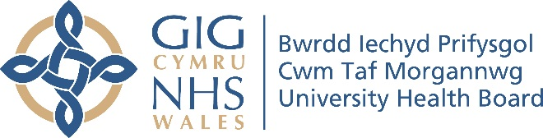 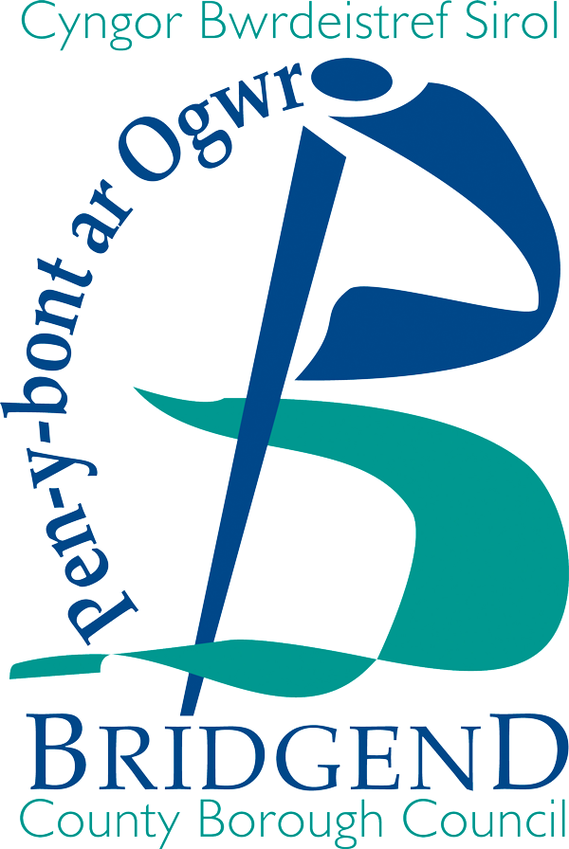 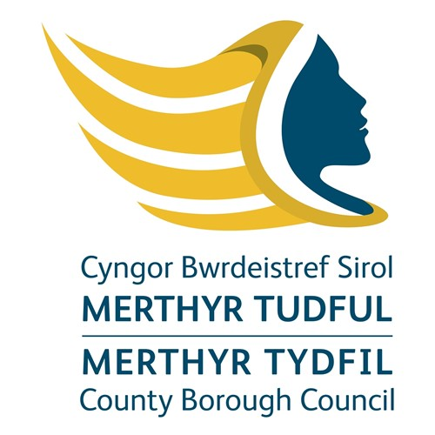

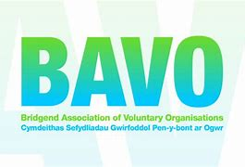 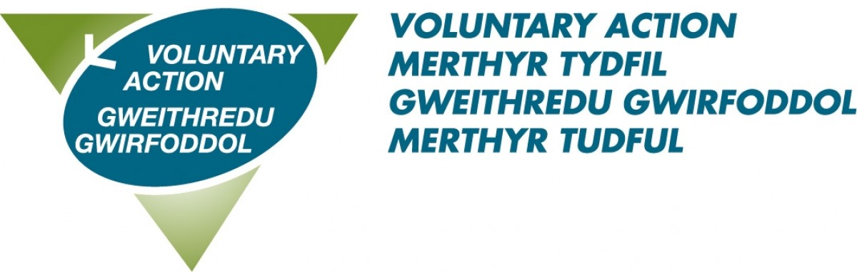 

**Cwm Taf Morgannwg Carers Grant 2022-23**

**Application Guidelines**

**The Vision for Carers in Cwm Taf Morgannwg is:**

**“Carers of all ages in Cwm Taf Morgannwg will be recognised and valued as being fundamental to supportive and resilient families and communities. They will not have to care alone and will be able to access information, advice and support to help meet their needs, empowering them to lead health and fulfilled lives, balancing their caring role and their life outside caring.”**

**AIM OF the CWM TAF MORGANNWG CARERS GRANT**

A Carer is someone who cares and supports someone who wouldn’t be able to manage without their help. Unpaid Carers who look after family, friends or neighbours are not the same as paid care workers or staff employed by health, social services, voluntary or private agencies.

The Cwm Taf Morgannwg Carers Grant is a one off grant of up to £5,000.00, £10,000 or £55,000 purposely set up for organisations who are/want to work in the Bridgend, Rhondda Cynon Taf and/or Merthyr Tydfil areas and is targeted at supporting Carers of all ages. Regional working is encouraged.

*It should be noted that many organisations already offer Carer focused projects, so it is imperative to engage with them as part of partnership working.*

Operating hours will be determined by the service provider, however these must be flexible and service user focused.

**FUNDING CRITERIA:**

**In response to current pressures on health and social care caused by Covid 19 and the resulting impact on hospital discharge processes, Ministers have agreed that unpaid Carers funding should focus on a single eligible activity - supporting unpaid Carers when the person they care for is discharged from hospital. This change is intended to aid timely discharge of patients from hospital by supporting and involving their unpaid Carers in the process.**

**Cwm Taf Morgannwg Statement of Intent for Carers 5 aims**:

1. Identifying Carers of all ages and recognising their contributions;
2. Providing up to date, relevant and timely information, advice and assistance to Carers of all ages;
3. Providing support, services and training to meet the needs of Carers of all ages;
4. Giving Carers of all ages a voice, with more choice and control over their lives;
5. Working together to make the most of our resources for the benefit of Carers of all ages.

The Fund will be managed by Cwm Taf Morgannwg University Health Board. This is a one-off fund. Larger grants will be paid quarterly. The project will be evaluated in order to inform any future funding opportunities.

Who Can Apply?

Applications are invited from organisations which are able to demonstrate that their goals will benefit individuals and/communities in Bridgend, Merthyr Tydfil and Rhondda Cynon Taf. Applicants must:

1. Be a not for profit group
2. Have a constitution or set of rules that have been signed or “adopted”
3. Have a Bank or Building Society account with at least two joint signatories
4. Have recent Annual Accounts or Statement of Income and Expenditure (audited or signed as approved by a senior person from the group)

NB: You will be required to submit copies of b) to c) detailed above.

If you are a new group, then you will be required to submit an estimate of expenditure.

**Grants**

A one off grant of up to £5,000.00, £10,000.00 and £55,000.00 is available.

* Grants are for Revenue costs only
* **Your project can start asap following confirmation of award**
* You must be able to spend the grant by the end of the financial year (March 2023)

If awarded, you will be required to sign up to Terms and Conditions which include provision of monitoring information as required. Monthly monitoring will be undertaken on all successful projects.

How are Applications Assessed?

Applications will be assessed by a Panel, comprising of representatives from BAVO, VAMT, Interlink, Bridgend, Merthyr Tydfil & Rhondda Cynon Taff County Borough Councils and Cwm Taf Morgannwg University Health Board.

What Help is Available to Assist in Putting Together THIS grant Application?

Cerys Gamble, Carers Coordinator, Cwm Taf Morgannwg University Health Board is available to provide advice in terms of discussing project ideas and completing the application form. However, the Carers Coordinator will not complete the application for you.

timetable

The deadline for submission of applications is 12 Noon on Monday 30th May 2022 – it is the applicant’s responsibility to ensure that completed applications are received by this date. Ideally applications will be submitted electronically and as such will receive an email receipt. Submit your application to:

|  |
| --- |
| Cerys Gamble  Carers Coordinator  Cwm Taf University Health Board  Ynysmeurig House  Abercynon  CF45 4SN  Cerys.gamble@wales.nhs.uk |

Applicants who are successful in securing funding must return their Grant Acceptance Form to Cerys Gamble within two weeks of receiving the grant offer letter. Failure to return the form by the deadline may result in forfeit of your award.

MONITORING AND EVALUATION

Gathering evidence from the very start of your project is essential as progress reports must be submitted half way and at the end of your project and successful applicants will be expected to maintain records in relation to qualitative and quantitative information, based on agreed performance indicators and using an outcomes framework.

Expenditure in relation to the project must be documented and all copies of invoices and receipts must be submitted for auditing purposes.

SCHEDULE

|  |  |
| --- | --- |
| Date/2022 | Description |
| 13th May | Launch of Carers Grant |
| 30th May | Deadline for applications (12 Noon) |
| w/c 13th June | Panel meet to review applications and make recommendations to the Cwm Taf Morgannwg Carers Partnership Group |
| w/c 13th June | Recommendations from the Panel to the Cwm Taf Morgannwg Carers Partnership Group |
| w/c 20th June | Recommendations from the Panel to the Transformation Leadership Group |
|  | Applicants notified of outcome |

For further information please contact:

Cerys Gamble, Carers Coordinator, Cwm Taf Morgannwg University Health Board cerys.gamble@wales.nhs.uk