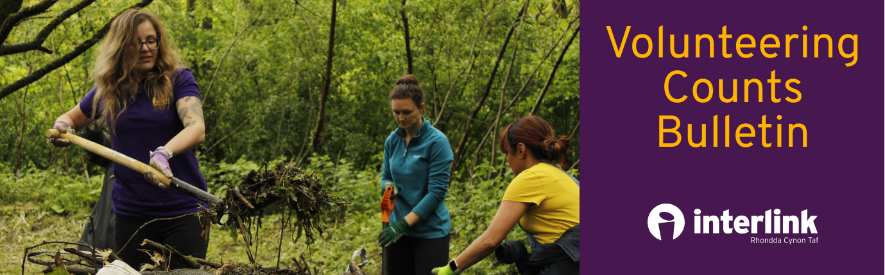
September 2021
Dear volunteer,

Welcome to our ‘Volunteering Counts Bulletin’. A bulletin produced to support you on your journey as a volunteer. Each month we will send you information and volunteering opportunities available within RCT.

In this month’s edition, find out about the newest volunteering opportunities, training for volunteers and some useful resources.

Support finding a volunteering opportunity
Our Community Advice Team are dedicated to supporting people of all ages find volunteering opportunities that suit them! If you would like to volunteer, please get in touch by emailing volunteer@interlinkrct.org.uk, or call our Volunteering Officer, Katelyn, on 07565472171.

Volunteering opportunities:
Elite Supported Employment
Elite Supported Employment have a variety of volunteering roles on offer including an administrative role, a mentor role and a recycling volunteer. You can find out more about each of these roles and express and interest in volunteering by calling 01443 226664.

Shelter Cymru
Shelter Cymru have a remote volunteering opportunity as part of their pathways programme. The role will involve using Shelter Cymru’s phone, email and web chat service to enable people to fight for homes. Shelter Cymru are primarily seeking to recruit volunteers with lived-experience of homelessness and law students. As such, preference may be given to such applicants. However, applications will be welcomed by all interested parties. Please get in touch with volunteer@interlinkrct.org.uk if you are interested.
The closing date is: 10am on Monday 4th October 2021.
Cynon Valley Museum
Cynon Valley Museum are looking for a front of house volunteer. The role will involve:
- meeting and greeting customers
- answering telephone calls
- operating the till
- upselling items in the shop
- ensuring all guests are following the COVID-19 guidelines and all areas are cleaned
The volunteer will need to be available Wednesday to Saturday. To apply or find out more please contact admin@cynonvalleymuseum.wales or call 01865 866729.

RCT Heart Heroes
RCT Heart Heroes have a variety of volunteering roles including a charity shop manager role, a school co-ordinator, an ambassador and public speaker as well as a fundraiser and an administrative role. If you are interested in finding out about any of the roles, please contact volunteer@interlinkrct.org.uk

Meadow Street Community
Meadow Street Community is a community garden in need of volunteers. The volunteer role involves:
- growing plants, flowers, fruit and veg
- assessing nature and biodiversity on the site
- helping to develop a new community project
- assisting with any community events on site
- buddying up with new volunteers
- making refreshments
This role will be carried out on a Saturday morning. For further information please contact Helen.williams@pontypriddtowncouncil.gov.uk.

Training and events:
Communities for Work
Communities for Work have the following training available:
- Budgeting, 1 day course on Friday 1st of October at 9.30am to 2.30pm
- Food Safety Level 2 at Mountain Ash Hub on Thursday 30th September, 9am to 4pm
To be referred to these training sessions please contact kburch@interlinkrct.org.uk.

Valleys Steps
Valleys Steps have a ‘Steps to Wellbeing’ course that is run weekly for six weeks. There are two sessions that you can attend and they start on 27th September at 2pm to 3pm or 6pm to 7pm and include:
Weekly Sessions at 2pm to 3pm:
- 27th Sept, Stress Management
- 4th Oct, Panic and Anxiety
- 11th Oct, Managing Difficult Thoughts
- 18th Oct, Breaking Free from Fear
- 25th Oct, Sleep
- 1st Nov, 5 Ways to Wellbeing
To register for the sessions, please follow the link below: https://valleyssteps.org/online-sessions/
Volunteering and World Mental Health Day 10th October
Volunteering can have a positive effect on mental health and wellbeing and can be valuable for the volunteer, as well as for the people who benefit from their help. Some of the benefits of using volunteering to help improve mental health include:
- A sense of purpose. Helping others can be rewarding and can give individuals a sense of responsibility and purpose.
- Building relationships. Volunteering can provide the opportunity to socialise and make new friends. Having positive relationships promotes mental wellbeing, and volunteering is a great way to build new relationships.
- Learning. Volunteering often involves learning new skills, which brings a sense of achievement.
- Employment. Many volunteering opportunities can be a pathway to employment and will allow individuals to build their confidence, develop their skills, and gain references.
- Distraction. Using distractions can help to improve your mental wellbeing and some may find that volunteering simply provides a welcoming distraction.
- Physical activity. Some volunteering activities may involve physical effort and the benefits of exercise for mental health are well established.

Connect RCT:
Connect RCT is the go-to community platform connecting volunteers, community and voluntary groups, and partners. Register now to:
- find out about and promote community activities and events in RCT
- connect with people and groups to support each other
- find and share information, advice and guidance
- share ideas and work together in teams
- discover and try out different volunteer opportunities
- recruit volunteers
You can register as a group or as an individual on www.connectrct.org.uk

Note to volunteers:
If you decide on any of the above, don’t forget to let us know. We’d love to hear from you!

Nothing of interest? Remember that new opportunities appear every month! Keep your eye on your inbox for our updates.

If you are interested in becoming a volunteer but are not sure what you would like to do, then please contact us.

As always, Interlink RCT staff are here to support you on your volunteer journey so please get in touch if you have any queries or questions. We are here to help.

Each month we will be producing a volunteering bulletin. If you’d like to promote anything or share information, please get in touch by emailing kburch@interlinkrct.org.uk
We have been requested to send you the volunteering bulletin. If you do not want to receive any further editions of it, please email info@interlinkrct.org.uk or call 01443 846200. If you have any queries or want further information, please contact sjames@interlinkrct.org.uk or call 07772 464110.

