 |  | 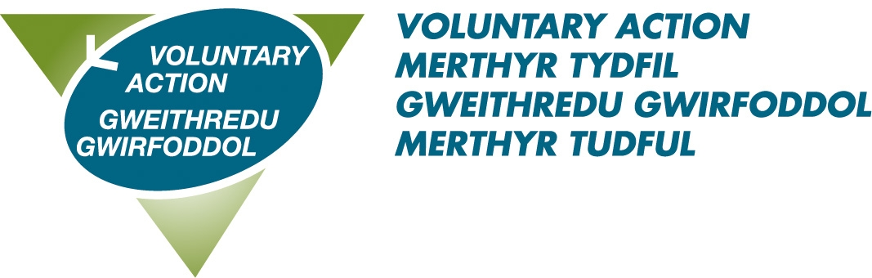 | 

Voluntary Sector Grant Scheme

Grants for projects that support short breaks for unpaid carers

Deadline: 16th August 2024 (12 Noon)

Supported by Welsh Government Amser Programme & Carers Trust Wales

Grants:
Grants of up to £10 000 are available for projects led by voluntary and community groups/organisations across Rhondda Cynon Taf and Merthyr Tydfil.
Purpose:
• Increase the availability and accessibility of short breaks for unpaid carers
• Provide personalised, flexible, and responsive break options for unpaid carers
• Prioritise and target short breaks to unpaid carers who most need it.
Outcomes:
• Unpaid carers and those they care for will have improved wellbeing
• Unpaid carers will be more resilient and able to sustain the caring relationship
• The voluntary sector will have increased capacity to deliver preventative, responsive breaks to unpaid carers.
Short Breaks:
Any form of assistance or service which enables an unpaid carer to have sufficient and regular periods away from their caring routine with the purpose of supporting the caring relationship and promoting the health & wellbeing of the carer and the supported person.
Short break activities include overnight stays, days out and shorter sessions such a regular activities and can be alone or with the person they care for.
Who For?
Projects will need to support one or more of the following beneficiary Groups:
• Unpaid carers of all ages
• Unpaid carers and the supported person
How to apply?
For an application form and guidelines click here.
For further information contact:
Anne Morris-Interlink RCT: 07736 587912 / 01443 846200 amorris@interlinkrct.org.uk
Claire Williams - VAMT: 07946 495306 / 01685 353984 claire.williams@vamt.net

